**Daily Market Wrap – 20 July 2018***by Anh Nguyen, 7:03PM BST*

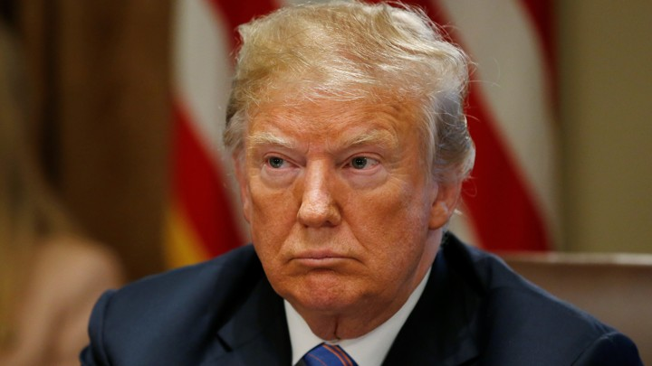

Markets have a hectic end to the week mainly due to US President Donald Trump. Mr Trump expressed his dislike for the strengthening Greenback yesterday evening then threatened to impose tariffs on all $505bn of Chinese import goods early this morning. He then followed by accusing China, EU and others of manipulating their interest rates and thus their currencies, as well as questioned the FED of its monetary tightening policy.

Equities

The **S&P 500** experienced a sell-off under the pressure of the global trade tensions, then recovered on the back of a quickly weakening US Dollar. It’s now back up to where it was yesterday, around the 2805 level.

Similar pattern is seen in the **FTSE**, which is trading near the 7620 level.

The **DAX** made week low at around 12455. The ongoing Brexit negotiation and German Chancellor Merkel reiterating that the EU is working on counter tariffs for autos also do not help to lift the German equities index.

FX

**CADUSD** had a strong rally by strong Canadian CPI and firm retail sales data released this morning. The upward movement is further support by a weakening US Dollar.

Both **EURUSD** and **GBPUSD** gained momentum to the upside following the Dollar U-turn. The former pair is now trading at 1.17680, while Cable broke through last week’s low around 1.3150.

Commodities

**Gold** seemed to finally reverse it recent downtrend, currently priced about 1230.

A quite day for **crude oil** as it keeps fluctuating around 68.40, after experiencing a huge rally yesterday on the back of Saudi exports projection.

*\* all products considered here are futures contracts with September 2018 front month*